3.7 Circular functions

What you should know
By the end of this subtopic you should be able to:
- recognise and interpret the graphs of the circular functions sine, cosine and tangent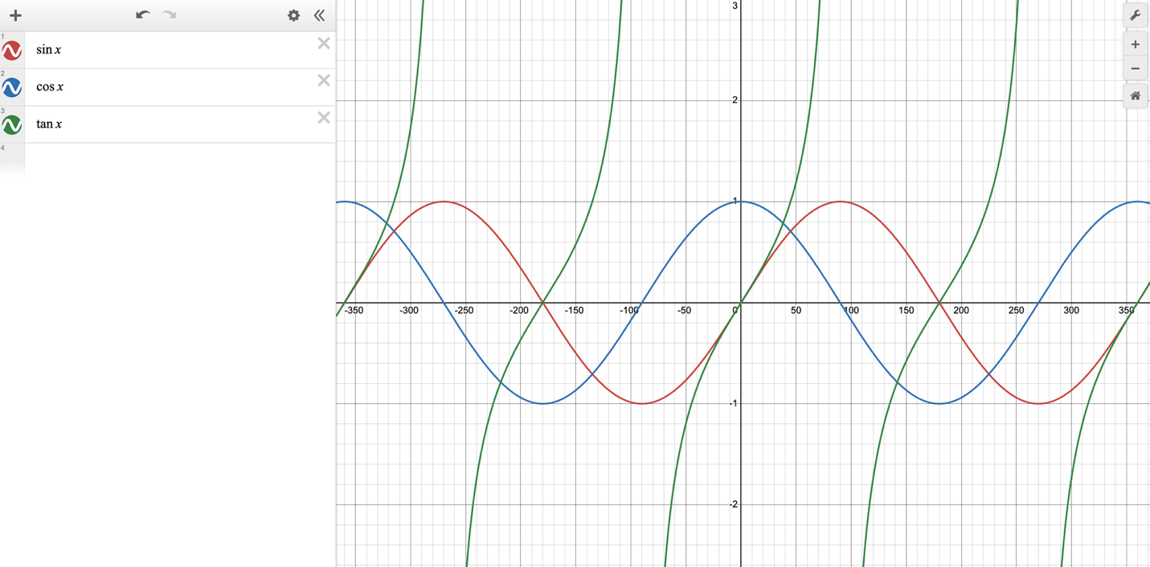
- use sine, cosine and tangent to solve problems involving the amplitude and period of periodic functions
- use composite functions of the form
$$f(x)=asin⁡(b(x+c))+d$$
- apply transformations to circular functions, including stretch and translation
- use trigonometric functions in real-life contexts

